John Marshall
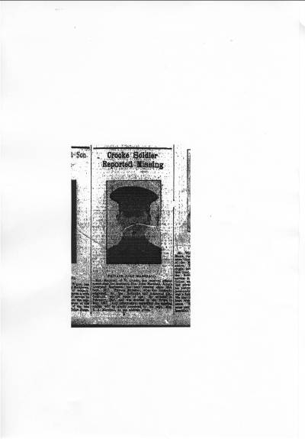
“Crooke Soldier Reported Missing” from the Wigan Observer, 10th November, 1917
“Mrs Marshall, of 75, Crooke, has received official notice that her husband, Pte John Marshall, King’s Liverpool Regiment, has been missing since 20th September, 1917. Private Marshall, who was formerly employed by the Roburite and Ammonal Co., Gathurst, was 32 years of age. He enlisted in February, 1917, and was drafted to the Front in May, 1917. Any information regarding the missing soldier will be gladly received by his wife, Mrs E A. Marshall, at the address given.”
John was a member of the 8th Battalion of Kings (Liverpool) Regiment, no. 203309.
John’s body was never identified. He is remembered at the Tyne Cot Memorial, and he probably died during the Battle of Passchendaele. Men who died in this area before 16th August 1917 are remembered at the Menin Gate at Ypres. Those who died after this date are remembered at Tyne Cot.
Tyne Cot is a large war cemetery, 9 kilometres north-east of Ieper (Ypres) in Belgian Flanders. How the name came about is not clear, but on British trench maps several farm buildings are marked with the names of other European rivers. “Cot” might be from “cottage” or from a Flemish word “duivekot”, “dovecote”.
In the cemetery there are 12,000 burials and the names of 35,000 men with no known grave. One of those is John Marshall from Crooke.
John’s family
Despite what the newspaper article says, John is described as a coal miner (tunneler, below surface) on the 1911 census form. He had married Elizabeth Ann Gibbons in 1907 and they had two children, Walter and Catherine.
John was born in 1885, the fourth of six children (in 1891) of James and Jane Marshall. Although James is described as a coal miner on the 1891 census, on a baptism certificate one year earlier he is described as a boatman, which might explain why four of the children were born variously in Worsley, Adlington, Runcorn and Skipton, which are all on the canal network.
James, the father, seems to have died, and Jane remarried in 1898 to James Cullen. He, then, may have died soon after that, because in the 1901 census, Jane (Cullen) is shown as head of the household. James Cullen is not mentioned. By this time, John had become a mate on a canal boat. His elder sister, Mary, worked in the pit, “screening, coal pit bank”, and a younger sister, Margaret, is described as “nurse girl (domestic)”.
John’s work
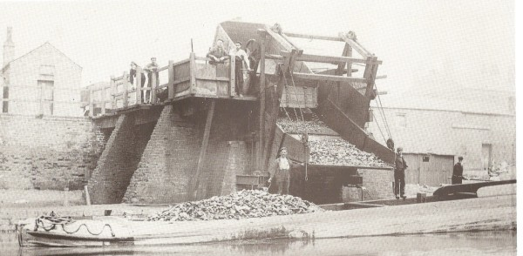
As well as being a miner, John also worked on canal boats.
Local coal mines provided much of the work on the canal near Shevington. Coal was loaded onto barges by the tippler at Crooke.

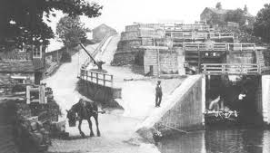
Barges would be pulled by horses . . .

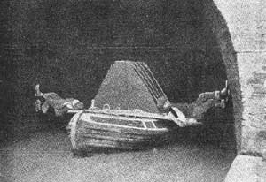
. . . but legged through tunnels.

What happened to John?
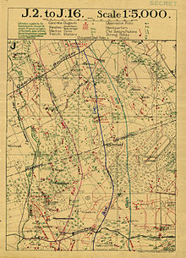
It seems most likely that John died during the Battle of the Menin Road Bridge, part of the Third Battle of Ypres, or the Battle of Passchendaele.
Map showing the British objective lines for the Battle of the Menin Road Bridge.

On 20 September the Allies attacked on a 14,500 yards (13,300 m) front and captured most their objectives to a depth of about 1,500 yards (1,400 m) by mid-morning. The Germans made many counter-attacks, beginning around 3.00 p.m. until early evening, all of which failed to gain ground or made only a temporary penetration of the new British positions on the Second Army front. The attack was a great success and showed that the German defences could no longer stop well-prepared attacks made in good weather. Minor attacks took place after 20 September as both sides jockeyed for position and reorganised their defences. A larger attack by the Germans on 25 September recaptured pillboxes at the south western end of Polygon Wood at the cost of heavy casualties. Not long after, the German positions near Polygon Wood were swept away by Plumer's attack of 26 September (the Battle of Polygon Wood). (from Wikipedia)
After 20th September, 1917, John Marshall, of 75 Crooke, was never seen again.

